Zachary Prole

Reflective Evaluation

Of The Master Project

Contents

Roles 2

Goals 2

Overview 2

Extract 2

Non-playable characters – Jack Bones 2

Desire Path 3

Volumetric Post-Processor 4

Puzzle – Pressure Plates 4

Object Oriented level design 5

Foliage Generator 5

Time Management 5

Overall Summary 6

Bibliography -Copy from research File 6

# Roles

In this project I was the sole designer in this project, however during the project production stage I did use asset packs to help myself, to make it clear to the review of my content, I will color the in-game folders according:

1. Green: My work I produced and developed
2. Blue: Asset packs I used in the game Production
3. A screenshot of a computer

   Description automatically generatedRed: Asset pack I downloaded, but didn’t use in the final iteration of the project

# Goals

## Overview

The goal for this project was to produce a “small scale” level, which would be able to tell a simple narrative without directly telling the player. This level would also have to be “Playable” with basic mechanics that supported the subtle narrative.

My second goal for this project was to use this project as material for my personal website, so that I can advertise myself after I finish this project.

## Extract

In my personal option I believe that this project has been an overall failure, however I believe that with more time given to this project, this could be rectified. The reason why I believe this is that the research I have gathered and analyzed is grounded and could be used to achieve this project goal, if someone would execute the practical side of this project more effectively.

# Non-playable characters – Jack Bones

Within my research I discovered a research article from Yale University stating that people will bond together if they experience the same events. I then decided to test this theory with my other game designer in a tabletop role playing game called “Dungeon and Dragons”. In this game the players make avatars for themselves to control, which can act in this fantasy environment. While doing this experiment, when one of the avatars was in a “risky” scenario within the game, I found that the players:

1. Paid more attention to the game to avoid mistakes.
2. Try and help the other players avatars at the risk of their own avatar.

This proved to me that players can emotionally bond with their avatar and the non-playable characters (NPC) around them, through playing the same game.

For this I had reason to believe that a player could bond with a non-playable character within a single player game. This then formed the bases on how I would tell a subtle narrative, as it would be hinted to the player using a non-playable character of Jack Bones.

I idea I had for this NPC was that the player would walk around the map, finding notes from this NPC, guiding the player to the right actions to proceed. I also wanted this NPC to be involved with the puzzles as well as be always beside the player, so that they could theoretically “bond”. I achieved this by creating weight-based puzzles, which the player had to drag the NPC ragdoll around to complete.

Unfortunately, I was not able to achieve my goal of the player constantly dragging the NPC around due to time restrictions and the poor planning of the practical side of this project. The problem I came across was that the NPC wouldn’t go through loading zones and would always end back at its spawn point. This took away from the idea that the player was moving it around if each time the map loaded the NPC, would be reset. In the end I still used the NPC weight mechanics, however I just placed new NPC in each zone, which took away from building this friendship with this NPC.

# Desire Path

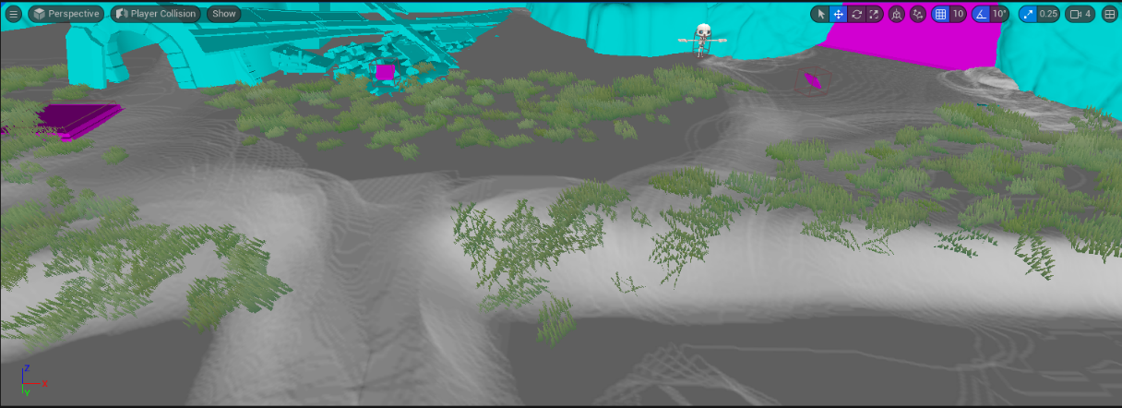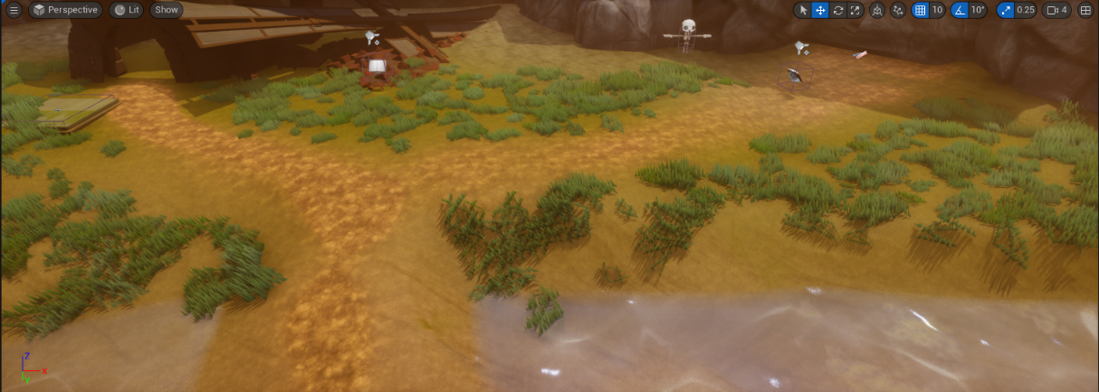When I was deigning my Environment, the terrain I designed had multiple paint layers that allowed me to blend colors on the ground. This allowed me to use a desired path theory, which I research to guild my player. This was done by trying to produce natural walkways, which the player would follow. I achieved this by choosing distinctive patterns for each layer so that it would be noticeable. What I also dd to achieve this is change the texture topology of the walkways to be rougher. The reason why I did this is that the player would subconsciously feel like there are two different zones, which are the smooth grassy patch vs the rough roads.

When it came to testing if the players would use the roads to guild them vs walking aimlessly, most players followed the path, however due to time restrictions I was not able to get many play testers, which makes these result indecisive as there were only five play testers. This amount is not satisfactory for approving a theory like this. What I can state is that I have noticed a pattern that approves of this theory, only if this patten scale with a broader number of play testers.

# Volumetric Post-Processor

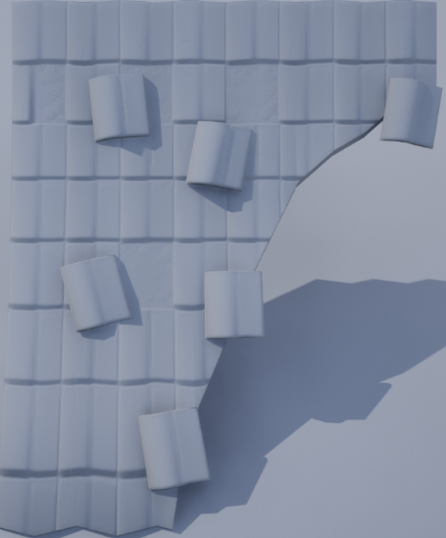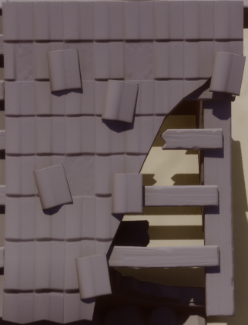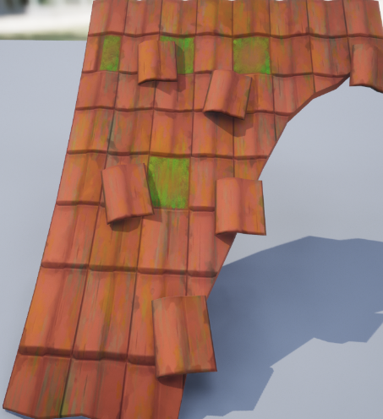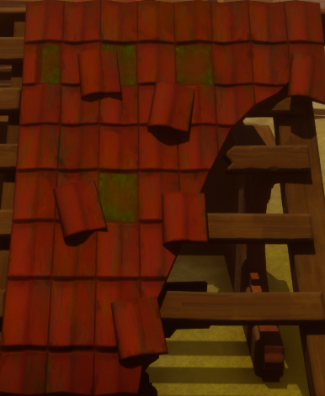

No Outline Shader With Outline Shader

No Color

With Color

When it came to the Volumetric Post-Processor (VPP), I was quite happy with the results because there was a noticeable difference with the assets in the world map. The shader did manage to make the world look more cartoonish, with the blocky shadows and feint outline, however this was not the first shader I implemented because the first one I made was far too aggressive for the art style I wanted.

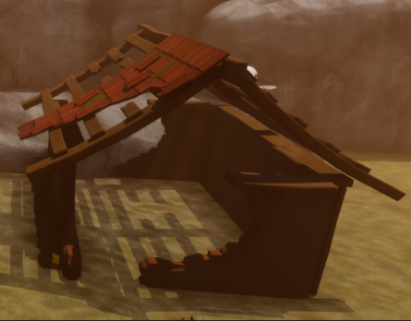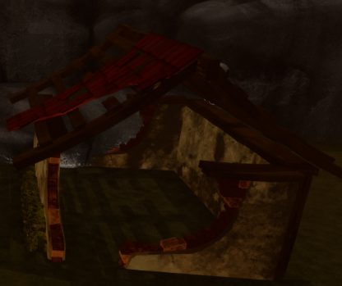

Same House with different VPP’S

These shaders did manage to add coherency to the level as all assets had this outlined styled to it.

# Puzzle – Pressure Plates

When it came to the pressure plate puzzle. I felt like it lacked something, even though it fitted with the concept of using the physic engine. I think the reason for this is that when the player steps on it, the experience feels underwhelming, for it to be the main mechanic. This means the players were less invested into the game, because of a lack of a core game loop.

What I should have done is more research into the physics engine I was using, so that I could find another puzzle concept, which I could have implemented alongside the pressure plates. If this would have happened, I believe that the core game loop, would have been more enjoyable, as then I could have applied the mechanical side of the Object-Oriented Level design, more fluently, as then the rule of three would have been more achievable if more mechanics was in place.

# Object Oriented level design

When it comes to the theory of object-oriented level design, it is used within my work, however I feel like it could be used in more and in more of a unique way. One of the reasons why I believe that I was not fully successful in this endeavor is that I didn’t have a strong time management scheme in place to keep myself on track for each theory and asset I wanted to implement. Where this theory has been used is in the building of my levels. What I mean by this is that all my buildings are destroyed in some way or another, which suggests to the player that an event has happened that they don’t know about. This sense of mystery given off by the dilapidated structures, does subtlety nod to an overall narrative within the level, however I am not impressed with it, as it is not to the scale, I imagined it to be. What I would have liked to create is a large object in the district, which the payer ventures towards, like a journey, and along the way discovering the lore of the world. This concept would be superior to my current project because it envelops most theories, I have researched within the year of studying my master’s degree.

What I did manage to achieve while using object-oriented level design is the way I designed to lore notes in the game. When it came to my research, I found that the way to draw players to objects within the environment was the intended object should be different from its surrounding to stand out. The reason why my note follows the core principles of object-oriented level design is that it has momentum. What I mean by this is that within my environment, excluding my water plane, everything has no movement, so by giving the note rotation, visually draw the player as it different from its surroundings.

Another example of myself using this method is the “doors” lifting and the button pressing down when there is enough mass on them. These also follow the same priceable of the notes because once the player interacts with these assets, they move and become abnormal to its environment.

Next time I use this theory, I plan to incorporate more methods of grabbing the player’s attention rather than purply relying on momentum. This could be done by an object making a sound in a silent game or the use of vibrant colors in a grayscale style of game.

# Foliage Generator

When it can to designing and implementing a foliage generator, I decided to cut it from the project. The reason why I made this decision is that this concept was not vital to the development of the core game loop, and I underestimated the time it took to develop the core features of the project. The purpose of the foliage generator for this project was to save time signally placing plants within the level, as the original plan was to have a large “Overworld” open space within the game, so when the overworld concept was shelfed due to time restrains, I also removed the need for the foliage generator, due to it no longer being necessary.

Another reason why I wanted to produce a foliage generator was the fact that its becoming more of an industry standard to have and create automation tools when you design a level. When I am producing a level, I like to try to keep to industry standard as much as possible, due to the fact that, when I get a job within the industry, their will be less time to adapt to their work environment. Another reason why it is important to try industry standard techniques, is that you can stay up to date with modern advancement within your field. This is the reason why I decided to make this game using the “Unreal Engine 5”, as it is currently one of the leading engines in game development. Doing this then gives me access to up-to-date material on how to fix problems with your game, as I am using up-to-date software. This material normally comes in the form of Unreal blog posts, talking about node functionality, if I ever get stuck.

# Time Management

During this project my time management has been poor for multiple reasons. The core two problems I had with time management were the fact that I was constantly ill, which I could not help, and the second problem was that I was prioritizing the wrong features in this project, rather than the necessary mechanics.

An example of this is that I spent far too long trying to get the player character working, when I could have used the based model and “re-skinned” it. This organization failure was due to me not following a structured time schedule, which in the end lead to a snowball effect. Stating this, if I was to do this project again, I would put more time into producing a structured time plan, so that I would be able to achieve more of my goals for this project.

# Overall Summary

The overall summary of my master’s project is that there is potential within this work, however this time I was not able to achieve what I desired to do. The main success of this project was the potentially successful implementation of the desired line theory. This suggests that video game design is a muti-disciplinary study, which borrows from a wide range of educational fields, like psychology. Another success of this project was the implementation of the Volumatic post processor. At first, I struggled to create a suitable theme for all the assets, as it was too dark and jarring, however with patience, and understanding on how the system work, I managed to correct it, in a way to be usable in my game.

Some of my downfalls of this game was the functionality of the loading zones, as it meant that the narrative didn’t make sense, and because of this I had to change the puzzles concepts last minute. This then had knock on effect, throughout the whole project. Another problem I faced was that due to my poor time management I let an important task snowball out of control.

To solve this problem next time when I must do a project like this, I would try and keep a tighter schedule so that I will know the feasibility of the project, before it gets out of hand. I also plan to allow for time where I will be unable to produce work, as this would allow leeway in the development stages of project to come.

Finally, when it comes to using this project as material to promote myself within the industry, it is my personal option that this project is too undeveloped to be shown with any pride and would properly hider my chances of finding a job in my industry in it current state. My next steps are to refine this work down into a more playable prototype, so that I can slowly make it into a web based mini game, to try and get my name out there, within my industry.

# Bibliography -Copy from research File

* Reinhard, A. (2018) *Archaeogaming: An introduction to archaeology in and of video games*. New York: Berghahn Books.
* Boothby, E.J., Clark, M.S. and Bargh, J.A. (2014) *Shared Experiences Are Amplified*, *Psychological Science*.
* SCHELL, J. (2008) *The Art of Game Design: A book of lenses*. Boca Raton ; London ; New York: CRC Press/Balkema.
* Kremers, R., 2022. [online] Linkin. Available at: <<https://uk.linkedin.com/in/rudolfk>> [Accessed 24 August 2023].
* Kayali, F. and Ortner, J., 2019. Level Design Practices for Independent Games. In: C. Totten, ed., Level Design Processes and Experieces, 1st ed. Florida: CRC Press, p.134.
* Doucet, L. (2010) Practical game design : The rule of threes, Game Developer. Available at: https://www.gamedeveloper.com/design/practical-game-design-the-rule-of-threes (Accessed: 24 August 2023).